1. Any development changes to be pushed between 6pm Melbourne time and 6am Melbourne time, not during the working day when testing is being completed
2. Ticket replies - #’s are still creating a new ticket while keeping the original ticket number in the subject, not continuing in same ticket # thread

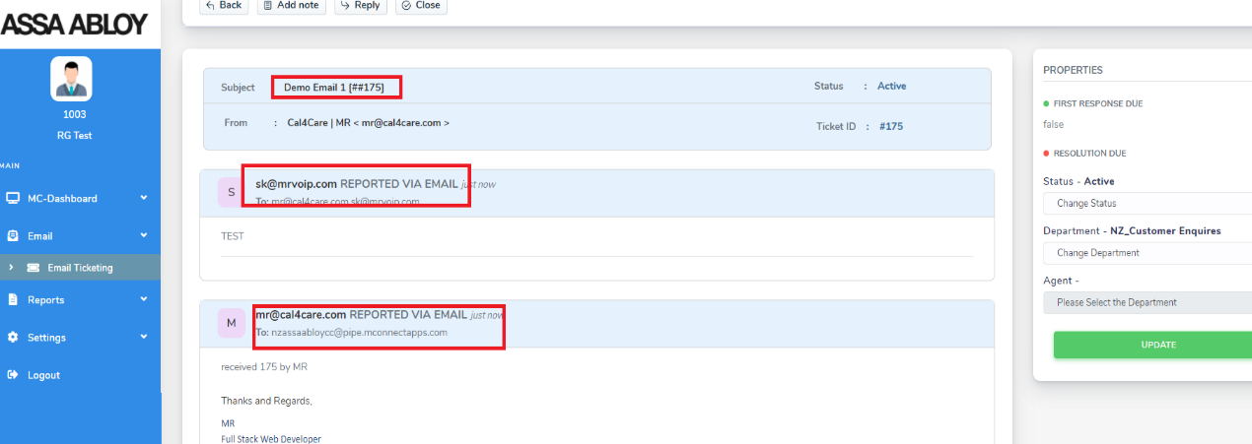

1. Wrap up report – column heading “Notes” needs to be aligned with the text underneath, - Refer to Richie’s email screenshot sent earlier.

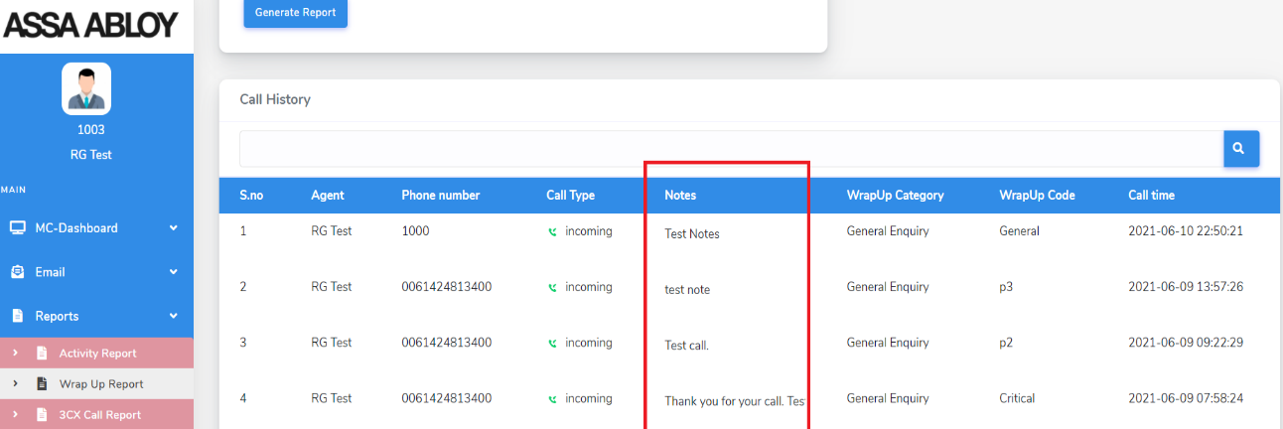

1. Add Note/Private Note on e-mail – Description should be the agent number/name not the e-mail address so it is known which agent has made that note

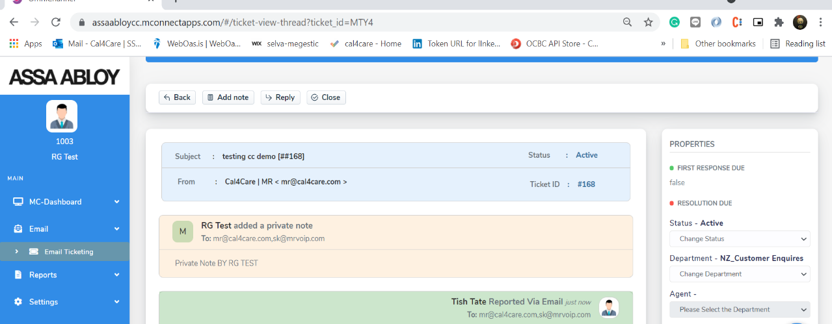

1. Admin & Agent E-mail – need to be able to add additional e-mail addresses to the reply – additional emails separated by a comma or semi-colon, Mani stated a button to add e-mail addresses – Need to Add CC and BCC

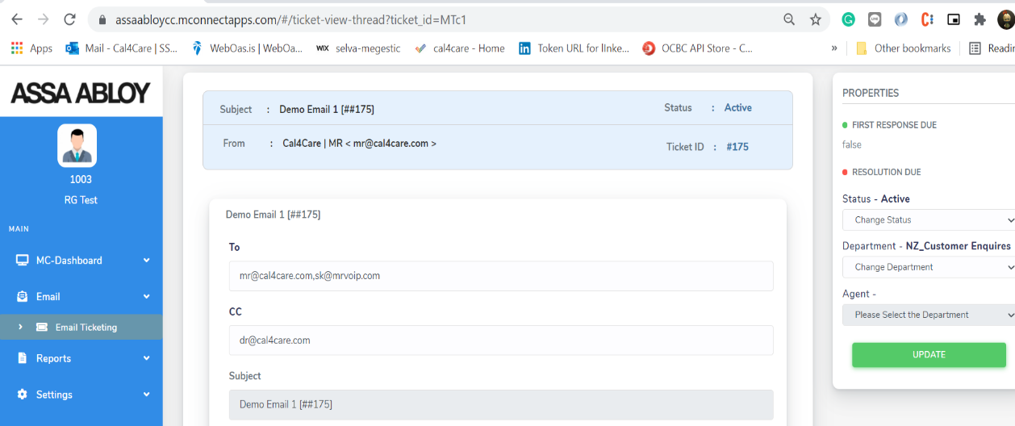

1. In Agent E-mail view – create new ticket, sends but the ticket does not close once sent just sits on the screen.  This is working in the Admin View so it is a behaviour issue in the User login as seen in today’s meeting

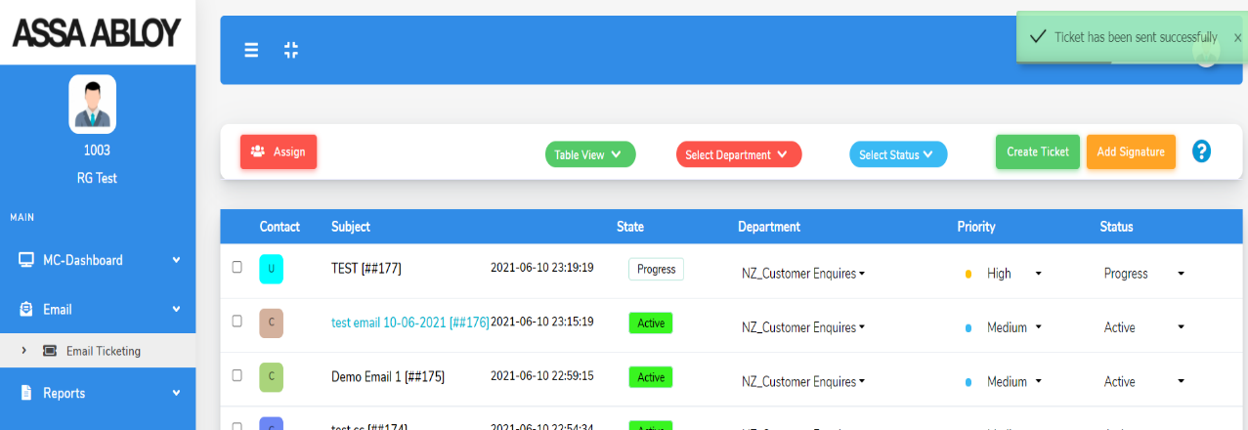

1. E-mail – skill-set assignment as per SOW, give agents priority for round-robin distribution based on their priority level – Mani to work on a solution
2. **Data Retention** – ASSA Abloy need for 7-10 years, MrVoIP keeps for 1 year only.  What are the options to keep this data – pay additional annual charges for storage OR store on ASSA Abloy server which I believe was discussed in a previous meeting?
3. User interface on agent view – change the exclamation mark ! to either a question mark ? or HELP button as is confusing on the User Interface.

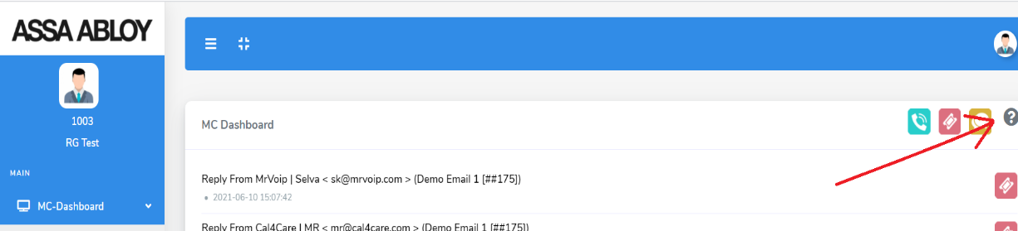

1. Get notified button needing to be pressed once per day to get latest e-mails **to be automated**.

DONE

1. When New E-mails  arrive in the email queues – the Admin UI refreshes correctly and shows the new emails – BUT this is not work in the Agent UI.  User is needing to refresh to see the e-mail, needs to be automatic.

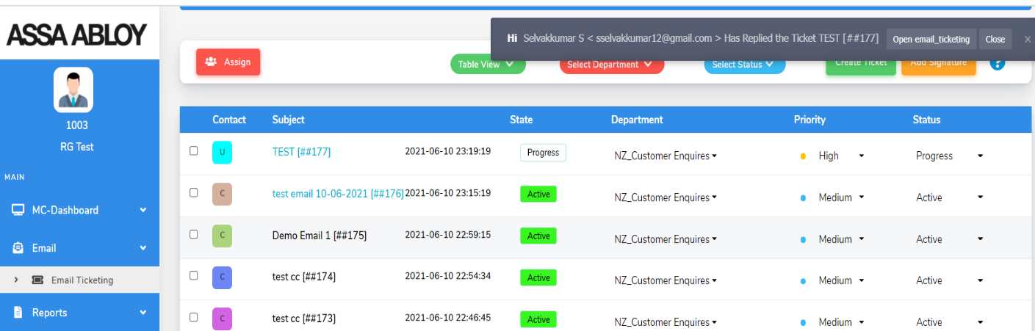

1. When a call comes in the customer  want to see the last 5 interactions from the caller (based off caller ID) can be shown or just phone calls – at present the phone calls only come up on the Timeline which is pulled from CRM.  They are asking about last 5 contacts however that has been – Mani to think and advise what may or may not be possible and what the implications will be.
2. Call recordings – should only be available to an admin to listen to, not an agent to download and listen to.

**From Agent:** 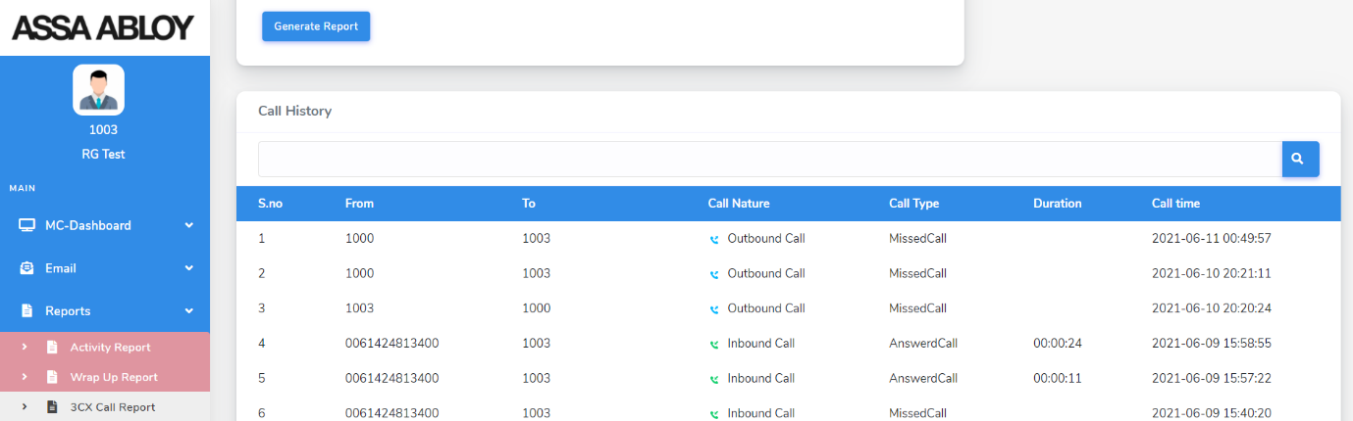

**From ADMIN:**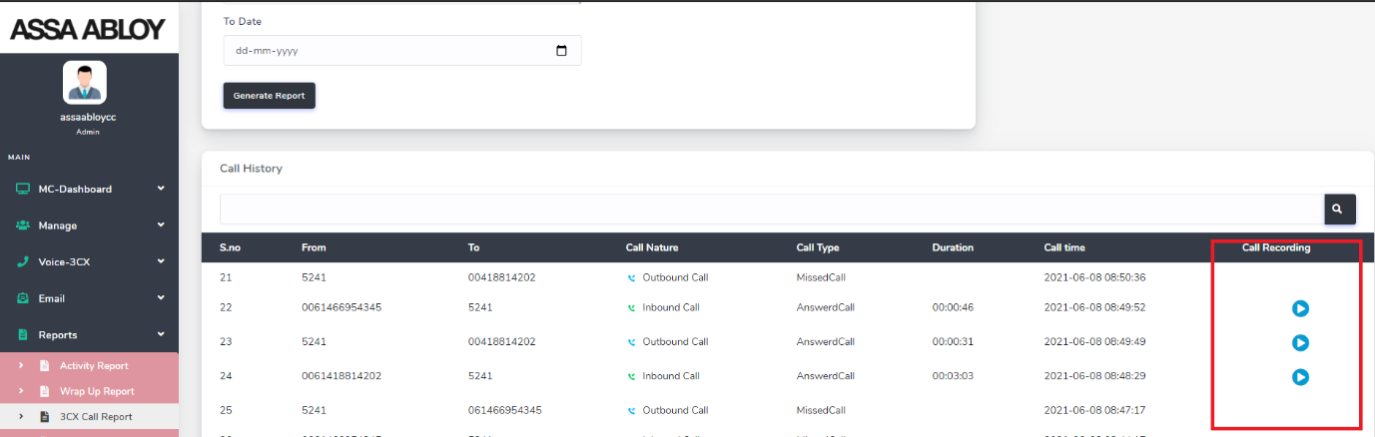

1. When a new call is presented to a user the wrap up code and notes fields should be cleared – currently only the wrap up code clears, **the notes field does not. As seen in today’s meeting**

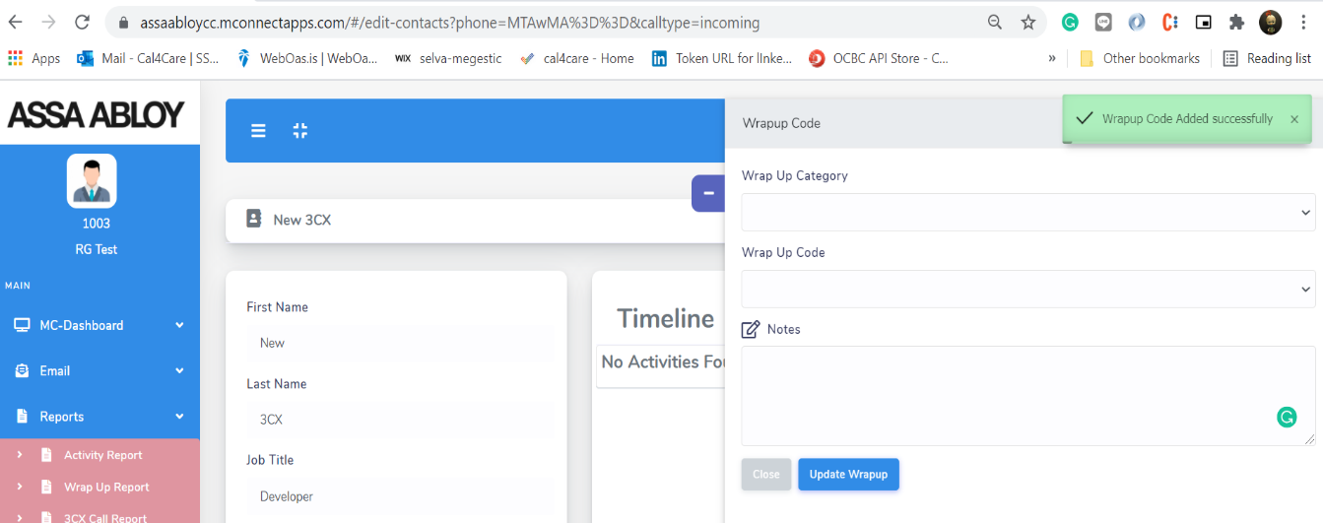

1. 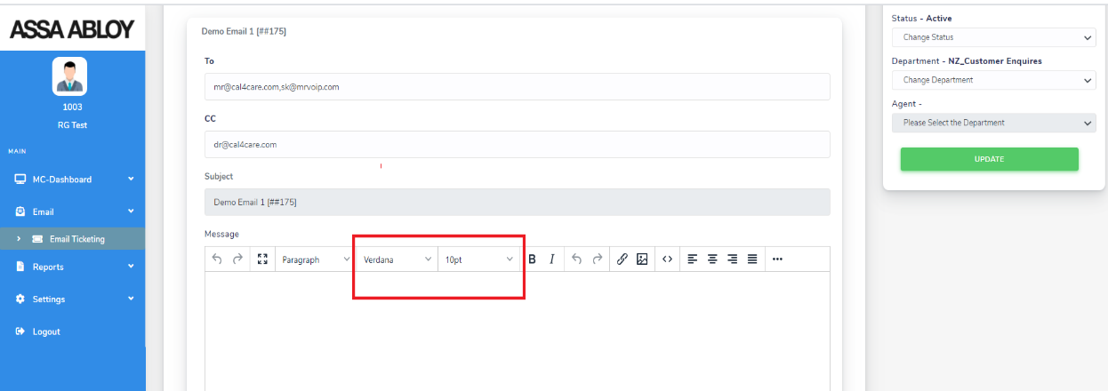E-mail text all to be font = **Verdana and size = 10** – this is for reply e-mails.
2. Can AU and NZ queues have different wrap up codes?  AU agents would not see the NZ codes and NZ agents would not see the AU codes.  **Is this possible?**
3. Wallboard – confusion as agent #’s available are incorrect.  **Omni is pulling wrong information and needs to be fixed**. As per our meeting the info from 3cx to Omni should be pulled from 3CX Queue Manager
4. Call queue announcement messages – incorrect numbers, Megan has e-mailed her 3CX Senior Engineer for advice around this.
5. Callbacks include a prefix so the CRM record is not found, 3CX is dropping the prefix and the call is connecting.  Omni needs to drop the prefix so the CRM Caller ID record is retrieved.
6. OmniChannel – logging out of queue, allows to select a queue to log out of but logs out of all so isn’t accepting the selection.  This is VERY important as agents are not always in every queue need to be able to log in or out of individual queues. Thilak mentioned he will work with 3CX engineers on this
7. E-mail Auto-response not going out to tell client their ticket number when an e-mail is received
8. Add time stamps in the email Queue View

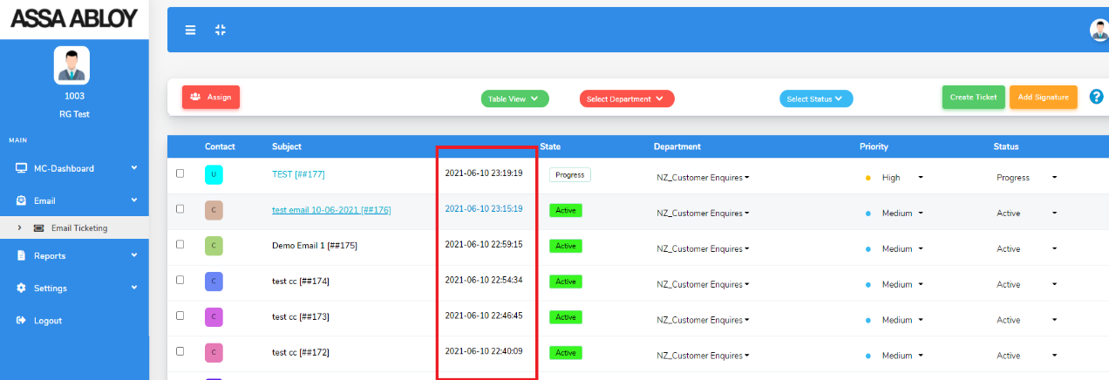

1. In MC Dashboard – if you click on the last interactions  - it does not take you to view the items clicked – please test

Fixed